ECON 101 – MACROECOMICS
FINAL EXAM
EXAMINER: MUHEBULLAH KARIMZADA
December 09, 2025

Instructions:
1. You have 120 minutes to work on the exam.
2. This exam is individual and closed-book.
3. For the multiple-choice questions, choose the option that best answers/completes the question.
4. This Examination paper includes 17 pages (includes the cover page). You are responsible for ensuring that your copy of the paper is complete. Bring any discrepancy to the attentions of your invigilator.

PLEASE: PUT YOUR NAME AND STUDENT ID ON EVERY SHEET!!

Multiple Choice Answers:

1. _________ 17. _________ 33. _________ 49. _________ 65. _________

2. _________ 18. _________ 34. _________ 50. _________ 66. _________

3. _________ 19. _________ 35. _________ 51. _________ 67. _________

4. _________ 20. _________ 36. _________ 52. _________ 68. _________

5. _________ 21. _________ 37. _________ 53. _________ 69. _________

6. _________ 22. _________ 38. _________ 54. _________ 70. _________

7. _________ 23. _________ 39. _________ 55. _________ 71. _________

8. _________ 24. _________ 40. _________ 56. _________ 72. _________

9. _________ 25. _________ 41. _________ 57. _________ 73. _________

10. _________ 26. _________ 42. _________ 58. _________ 74. _________

11. _________ 27. _________ 43. _________ 59. _________ 75. _________

12. _________ 28. _________ 44. _________ 60. _________ 76. _________

13. _________ 29. _________ 45. _________ 61. _________ 77. _________

14. _________ 30. _________ 46. _________ 62. _________. 78. _________

15. _________ 31. _________ 47. _________ 63. _________ 79. _________

16. _________ 32. _________ 48. _________ 64. _________ 80. _________
MULTIPLE CHOICE. Choose the one alternative that best completes the statement or answers the question.

Table 5.15
Year | Nominal Average  Hourly Earnings | CPI
2017 | $15 | 100
2018 | 15 | 105
2019 | 18 | 110

1) Refer to Table 5.15. Looking at the table above, real average hourly earnings were equal to ________ in 2018.
A) $13.63
B) $14.29
C) $15.00
D) $16.50
E) $18.36

2) Suppose the economy is at a short-run equilibrium GDP that lies below potential GDP. Which of the following will occur because of the automatic mechanism adjusting the economy back to potential GDP?

A) Short-run aggregate supply will shift to the right.
B) Aggregate demand will shift to the right.
C) Unemployment will rise.
D) Prices will increase.
E) Output will decrease.

Figure 7.3

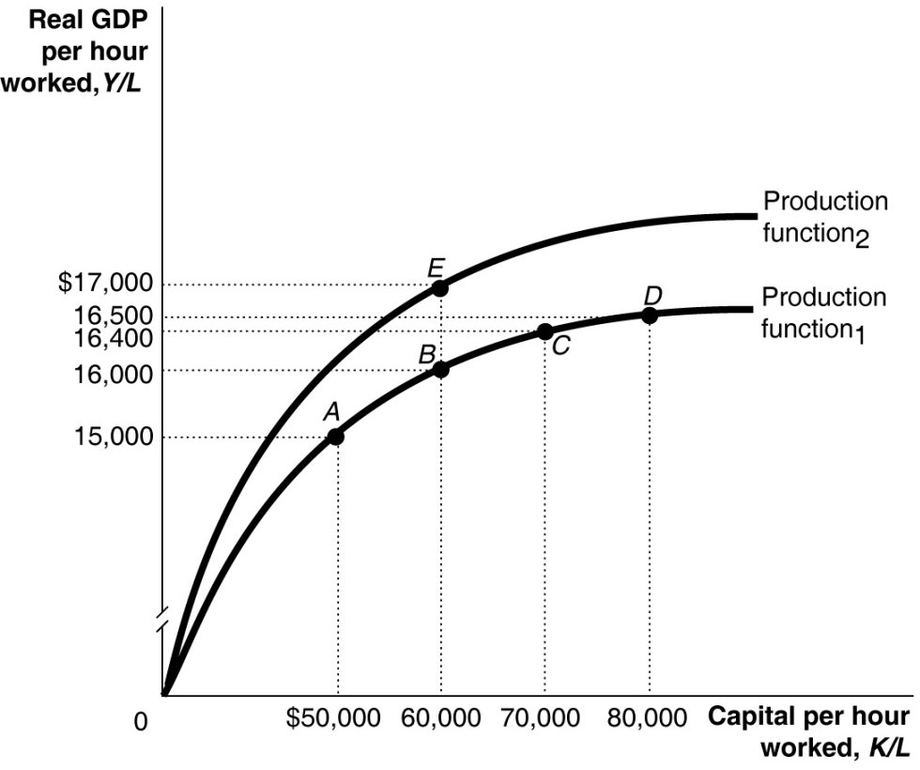
3) Refer to Figure 7.3. A large group of new workers entering the labour force is shown in the figure above by a movement from

A) A to B.
B) B to E.
C) C to D.
D) E to B.
E) C to B.

4) Which of the following is not counted in M1+?

A) currency in circulation
B) credit card balances
C) non-chequable deposits
D) coins in circulation
E) chequing account balances

Figure 8.3

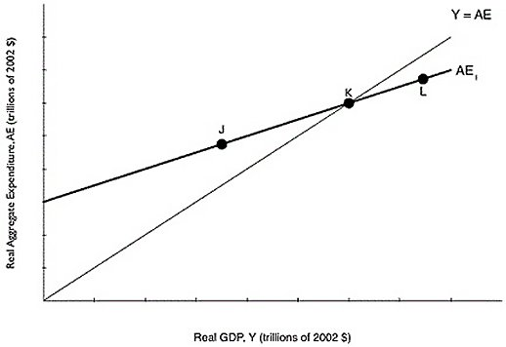
5) Refer to Figure 8.3. If the economy is at point J, what will happen?
A) Inventories have fallen below their desired level, so firms will decrease production.
B) Inventories have risen above their desired level, so firms will increase unplanned inventory investment.
C) Inventories have fallen below their desired level, so firms will increase production.
D) Inventories have risen above their desired level, so firms will decrease production.
E) Inventories have fallen below their desired level, so firms will decrease unplanned inventory investment.

6) Which of the following would be the best measure of the cost of living?
A) real GDP per person
B) real GDP
C) purchasing managers' index
D) consumer price index
E) GDP deflator

7) When lumber from Brazilian forests is used by a U.S.-owned company to produce furniture in Canada, the value of the furniture produced will be counted as a final good in

A) Brazil's GNP.
B) Brazil's GNI.
C) Brazil's GDP.
D) U.S. GDP.
E) Canada's GDP.

8) Using the money demand and money supply model, an open market sale of government of Canada securities by the Bank of Canada would cause the equilibrium interest rate to

A) increase.
B) decrease.
C) not change.
D) increase, then decrease.
E) decrease, then increase.

Table 4.21
 | 2019 | 2020
Nominal GDP | $10,000 | $12,000
Real GDP | 9,500 | 10,500

9) Refer to Table 4.21. Given the information above, calculate the GDP deflator in 2019.

A) 87
B) 95
C) 100
D) 105
E) 114

10) The two main monetary policy tools used by the Bank of Canada to implement monetary policy are
A) tax rates and lending to financial institutions.
B) open market operations and lending to financial institutions.
C) tax rates and printing money.
D) lending to financial institutions and changing the desired reserve ratio.
E) open market operations and tax rates.

11) In a small Asian country, it is estimated that a $10,000 increase in capital per hour worked will increase real GDP per hour worked by $600. Based on this information, what is the slope of the per-worker production function in this range?

A) 0.0
B) 0.06
C) 0.6
D) 6.6
E) 66.6

12) If real GDP grows by 7.0% in 2018, falls by 3% in 2019, and grows by 6% in 2020, what is the average annual growth rate of real GDP?

A) 1.4%
B) 2.9%
C) 3.3%
D) 4.2%
E) 5.3%

13) The purchase of a new house is included in

A) government purchases.
B) exports.
C) imports.
D) investment expenditures.
E) consumption expenditures.

14) Which of the following could explain why there is an increase in potential GDP but the equilibrium level of GDP does not rise?

A) SRAS and AD do not shift.
B) AD shifted to the right by more than SRAS.
C) SRAS shifted to the right by more than LRAS.
D) The shift in LRAS was caused by a rise in investment.
E) AD shifted to the right by less than SRAS.

15) In preparing their estimates of the economic impact of a new football stadium in the City of Regina, proponents argued that building the stadium would create twice as much economic activity in the city as the stadium was projected to cost (essentially arguing that the local multiplier was 2). This is likely to be an overestimate of the multiplier because

A) construction projects generate no additional economic activity.
B) Regina's marginal propensity to consume is too great.
C) imports and income taxes will reduce the impact of new spending.
D) the price level in the local economy is likely to be insensitive to a major construction project.
E) the marginal propensity to save in Saskatchewan is much higher than in other parts of the country.

16) Which of the following explains the changes in the Canadian adult male labour force participation rate since 1976?
A) Younger men are remaining in school longer as compared to the past.
B) More men are retiring later in life as compared to the past.
C) There are fewer working age males than in the past.
D) Fewer men consider themselves discouraged workers as compared to the past.
E) More men are joining the military as compared to the past.

17) A monetary growth rule means that
A) the money supply should grow in response to economic conditions.
B) the Bank of Canada will lower interest rates if it thinks a recession is on the horizon.
C) the money supply should grow at the same rate as the population.
D) the money supply should grow at a constant rate.
E) the Bank of Canada will raise interest rates if it thinks the economy is growing faster than potential.

18) When U.S. GDP grows more slowly compared to Canada,
A) Canadian firms will export less, leading to slower Canadian GDP growth.
B) Canadian prices will rise more quickly causing household disposable income to fall in Canada.
C) Canadians will export some of the newly made Canadian goods, causing U.S. GDP to shrink.
D) government spending in Canada will likely decrease.
E) Canadian firms will invest more, causing domestic investment to rise and Canadian GDP to fall.

19) If GDP is currently growing at 28 % a year, the velocity of money is growing at 1% a year, and the growth rate of money supply is 15%, what rate of inflation can this country expected based on the quantity theory of money?

A) 0.5%
B) 44%
C) 12%
D) -12%
E) -13%

20) If Canada and Bolivia have annual per capita growth rates of 3.2% and 1.35%, respectively, and if Canada's per capita GDP is higher, then in the long run

A) the difference between the level of real GDP per capita in Canada and real GDP per capita in Bolivia will equalize over time.
B) the difference between the level of real GDP per capita in Canada and real GDP per capita in Bolivia will always be $1.9 trillion.
C) the difference between the level of real GDP per capita in Canada and real GDP per capita in Bolivia will shrink over time.
D) real GDP per capita in Canada will always be 1.9% higher than real GDP per capital in Bolivia.
E) the difference between the level of real GDP per capita in Canada and real GDP per capita in Bolivia will increase over time.

21) High-income countries have ________ and ________ as compared to developing countries.

A) high rates of savings; high rates of unemployment
B) low rates of savings; high rates of growth
C) high rates of savings; high rates of growth
D) low rates of savings; low rates of growth
E) low rates of savings; low rates of unemployment

22) Which of the following causes the unemployment rate to understate the true extent of joblessness?

A) Some people do not want to have a paid job.
B) Persons who collect unemployment benefits report themselves to be searching for a job.
C) Discouraged workers are not counted as unemployed.
D) A drug dealer reports herself as unemployed.
E) Many full-time workers really want to be part-time workers.

23) In a small economy in 2016, aggregate expenditure was $850 million while GDP that year was $800 million. Which of the following can explain the difference between aggregate expenditure and GDP that year?

A) Aggregate expenditure is always less than GDP in developed countries.
B) Aggregate expenditure does not account for consumer spending.
C) Firm investment in inventories was greater than anticipated in 2016.
D) Firm investment in inventories was less than anticipated in 2016.
E) Aggregate expenditure is always less than GDP in developing countries.

24) Most economists believe that the return of ________ during the 2008-2009 recession is a key reason why the recession was so severe.

A) high interest rates
B) rapid inflation
C) high unemployment
D) financial instability
E) high tariffs

25) The largest component of spending in GDP is

A) wages.
B) government spending.
C) investment spending.
D) household spending.
E) net export spending.

26) There are no costs to inflation if it is fully anticipated.
A) True
B) False

27) A decrease in which of the following would decrease the tax wedge?
A) federal budget deficit
B) money supply
C) property taxes
D) marginal tax rate
E) national debt

28) An increase in ________ shifts the production function ________, and makes it possible to produce a higher level of GDP with ________ capital per hour worked.
A) technology; down; the same amount of
B) technology; up; the same amount of
C) labour productivity; down; the same amount of
D) capital stock; up; a lesser amount
E) consumption; up; a lesser amount

29) In October 2008, U.S. Congress passed the Troubled Asset Relief Program (TARP), under which the U.S. Treasury Department provided ________ to banks in exchange for ________.
A) lines of credit; loan guarantees
B) deposits; new mortgage loans
C) financial advice; promises to expand mortgage lending
D) bonds; cash
E) funds; stock

30) The decrease in consumer spending during the 2008-2009 recession was due in part to falling prices in the stock market. The reason for the decline in consumer spending is most closely related to which of the following variables that determine the level of consumption?
A) household wealth
B) the price level
C) the interest rate
D) government transfers
E) current disposable income

31) Paul Romer, an economist at Stanford University, is most closely associated with what economic theory?
A) the quantity theory of money
B) the Communist Manifesto
C) the process of creative destruction
D) new growth theory
E) labour productivity theory

32) Which of the following would not be included in the expenditure category called investment expenditures?
A) a purchase of a copy machine by Purolator Courier's head office
B) the purchase of a new airplane by Air Canada
C) the cars held in inventory on a local Ford dealer's lot
D) a purchase of shares of preferred stock
E) spending on new houses

33) Suppose real GDP is $1.4 trillion and potential GDP is $1.9 trillion. To move the economy back to potential GDP, the federal government should
A) lower taxes by an amount less than $500 billion.
B) lower taxes by $500 billion.
C) lower government purchases by $500 billion.
D) raise government purchases by more than $500 billion.
E) raise government purchases by $500 billion.

34) An increase in the purchasing power of money would not, on average, result in an increase in the purchasing power of people's income because a ________ price level would likely mean ________ wages and salaries.
A) falling; falling
B) rising; falling
C) falling; rising
D) falling; no changes in
E) rising; rising

35) Which of the following is an objective of fiscal policy?
A) drug plan coverage for all Canadians
B) winning hockey gold at the winter Olympics
C) discovering a cure for AIDs
D) energy independence from Middle East oil
E) high rates of economic growth

36) Georg, a German citizen, just purchased 10 shares of stock in Suncor, a Canadian company. This purchase is an example of
A) foreign direct investment.
B) domestic fixed capital formation.
C) foreign public investment.
D) foreign portfolio investment.
E) contractual globalization.

37) Given the equations for C, I, G, and NX below, what is the equilibrium level of GDP?

C = 1,000 + 0.8Y
I = 1,500
G = 1,250
NX = 100

A) $3,080
B) $3,850
C) $6,930
D) $19,250
E) $38,500

38) The Bank of Canada uses ________ to measure inflation.
A) the personal consumption expenditures index
B) the consumer price index
C) the index of leading economic indicators
D) the producer price index
E) the GDP deflator

39) The "new economy" which some economists believe can lead to higher productivity growth in the future is based on
A) financial services.
B) retail sales.
C) manufacturing.
D) information technology.
E) natural resource extraction.

40) Discouraged workers are classified by Statistics Canada as
A) employed.
B) out of the labour force.
C) part of the labour force.
D) part-time employees.
E) unemployed.

41) If planned aggregate expenditure is greater than total production,
A) actual inventories will equal planned inventories.
B) GDP will increase.
C) firms will experience an unplanned increase in inventories.
D) the economy is in equilibrium.
E) governments are likely to experience growing budget deficits.

42) The body that is responsible for dating the beginning and ending dates for a recession is
A) Canadian Parliament.
B) the Association of Chief Economics of Canadian Banks.
C) the Bank of Canada.
D) Statistics Canada.
E) There is no such body in Canada.

43) Which of the following explains why the unemployment rate tends to rise as a recession ends?
A) The birth rate tends to rise during recessions.
B) Firms reducing hiring as recessions come to an end.
C) The federal government uses a different definition of "unemployed" during recession.
D) Discouraged workers begin to search for jobs.
E) Employment insurance tends to be more generous during recessions.

44) Which of the following is considered a negative supply shock?
A) a decline in wages
B) an unexpected increase in the price of natural gas
C) an improvement in technology
D) increasing investment in the economy causes the capital stock to rise
E) a drop in investment spending

45) Which of the following would decrease the unemployment rate?
A) government aid to retrain unemployed workers
B) an increase in labour union membership
C) an increase in the efficiency wage
D) an increase in the minimum wage
E) an increase in the generosity of Employment Insurance payments

46) If, in a closed economy, real GDP is $30 billion, consumption is $20 billion, and government purchases are $5 billion, what is total saving in the economy?
A) $5 billion
B) $15 billion
C) $25 billion
D) $45 billion
E) $55 billion

47) Which of the following will cause a direct increase in consumption spending?
A) an increase in income taxes
B) a decrease in net export spending
C) an increase in government spending
D) an increase in disposable income
E) an increase in planned investment

48) Short-run macroeconomic equilibrium occurs when
A) aggregate demand and short-run aggregate supply intersect.
B) the equilibrium lies on the long-run aggregate supply curve.
C) structural unemployment equal zero.
D) cyclical unemployment is equal to zero.
E) frictional unemployment equal zero.

49) In the long run,
A) the aggregate demand curve becomes flat.
B) GDP > potential GDP.
C) LRAS and SRAS lie on the same line.
D) the inflation rate is zero.
E) unemployment is at its natural rate.

50) Which of the following tools of monetary policy is used least often?
A) acting as a lender of last resort
B) sale and repurchase agreements
C) purchase and resale agreements
D) printing more money
E) setting the overnight interest rate

Table 4.20
 | 2018 |  | 2020
Product | Quantity | Price | Quantity | Price
Cameras | 100 | $10 | 120 | $12
Legal services | 50 | 15 | 45 | 20
Books | 200 | 40 | 210 | 45

A very simple economy produces three goods: cameras, legal services, and books. The quantities produced and their corresponding prices for 2018 and 2020 are shown in the table above.

51) Refer to Table 4.20. What is real GDP in 2020, using 2020 as the base year?
A) $28,885
B) $11,790
C) $11,200
D) $10,275
E) $8,750

52) Which of the following is most liquid?
A) a painting
B) a government bond
C) a mutual fund share
D) a five dollar bill
E) a corporate bond

53) A decrease in the real interest rate will
A) cause consumers to spend less and save more.
B) most likely increase the reward to savings.
C) most likely increase consumer purchases of durable goods.
D) most likely transfer wealth from borrowers to lenders.
E) most likely increase the cost of borrowing.

54) An increase in net national income could be caused by which of the following?
A) an increase in gross domestic product
B) an increase in housing costs
C) an increase in personal taxes
D) an increase in depreciation
E) a decrease in personal income

55) An increase in aggregate demand in the economy will have what effect on macroeconomic equilibrium in the long run?
A) The price level will rise and the level of GDP will be unaffected.
B) The price level will be unaffected and the level of GDP will rise.
C) The price level will fall and the level of GDP will fall.
D) The price level will fall and the level of GDP will rise.
E) The price level will rise and the level of GDP will fall.

56) Using the quantity equation, if the velocity of money grows at 5 percent, the money supply grows at 10 percent, and real GDP grows at 4 percent, then the inflation rate will be
A) 11 percent.
B) 19 percent.
C) 14 percent.
D) 15 percent.
E) 6 percent.

57) The per-worker production function has a ________ slope, indicating that increases in capital per hour worked ________ real GDP.
A) negative; increase
B) positive; decrease
C) negative; decrease
D) positive; increase
E) vertical; decrease

58) The Bank of Canada maintains an operating band for the overnight interest rate of
A) 50 basis points above the prime rate.
B) 50 basis points below the bank rate.
C) 50 percent of the bank rate.
D) 50 basis points below the inflation rate.
E) 50 percent of the inflation rate.

59) The aggregate demand curve will shift to the right ________ the initial decrease in taxes.
A) by less than
B) by more than
C) by the same amount
D) sometimes by more than and other times by less than
E) None of the above.

60) If the government purchases multiplier equals 2, and real GDP is $1.7 trillion with potential real GDP of $1.75 trillion, then government purchases would need to increase by ________ to restore the economy to potential real GDP.
A) $1.75 trillion
B) $500 billion
C) $100 billion
D) $50 billion
E) $25 billion

61) Increases in real GDP since 1961 can actually underestimate growth in the standard of living for Canadians because
A) the crime rate was higher in 1961 than it is today.
B) goods and services are more expensive today as compared to 1961.
C) fewer women participated in the paid labour force in 1961.
D) the level of pollution in 1961 was much higher than it is today.
E) the quality of health care that exists today was not available in 1961.

62) Which of the following best describes the "wealth effect"?
A) When the price level falls, the nominal value of household wealth falls.
B) When the price level falls, the nominal value of household wealth rises.
C) When the price level falls, the value of stocks rise.
D) When the price level falls, the real value of household wealth falls.
E) When the price level falls, the real value of household wealth rises.

63) If nominal GDP exceeds real GDP for a specific year, then the GDP deflator must be
A) greater than 100.
B) less than 100.
C) equal to its value in the base year.
D) equal to 100.
E) less than 0.

64) Poorly timed discretionary policy can do more harm than good. Getting the timing right with fiscal policy is generally
A) about the same difficulty as with monetary policy.
B) far less difficult than with monetary policy.
C) less difficult than with monetary policy.
D) more difficult than with monetary policy.
E) impossible due to the interference from the Bank of Canada.

65) On the 45-degree line diagram, the 45-degree line shows points where real aggregate expenditure equals
A) unplanned investment.
B) real GDP.
C) planned investment.
D) potential GDP.
E) nominal GDP.

66) A commercial bank like Bank of Montreal creates money by
A) making loans.
B) earning profits.
C) selling corporate bonds.
D) distributing new currency printed by the Canadian mint.
E) printing paper money.

67) Caroline is an artist. She purchases canvas, paints, brushes, and accessories for $75. She sells one of her original paintings to an art gallery for $1,500. The gallery, in turn, sells the painting to an art lover for $4,500. How much value does the gallery add?
A) $1,425
B) $1,500
C) $3,000
D) $4,500
E) $5,075

68) Which of the following would be a consequence of substitution bias in the CPI?
A) Businesses would overcompensate employees for inflation when giving the cost of living rises.
B) The inflation rate based on the CPI would underestimate the true level of inflation.
C) Social Security payments would not adequately compensate retired workers for inflation.
D) Economists make errors in estimating inflation when using substitutes for the CPI such as GDP deflator.
E) Judges would award child support payments that would not adequately keep up with the true cost of inflation.

69) If the economy receives an influx of new workers from immigration,
A) the aggregate demand curve will shift to the left.
B) we will move up along the long-run aggregate supply curve.
C) the long-run aggregate supply curve will shift to the right.
D) we will move down along the long-run aggregate supply curve.
E) the long-run aggregate supply curve will shift to the left.

70) Which of the following is an example of human capital?
A) a university or college education
B) a software program
C) computers used by human resource departments
D) a factory building
E) a computer

Figure 9.3

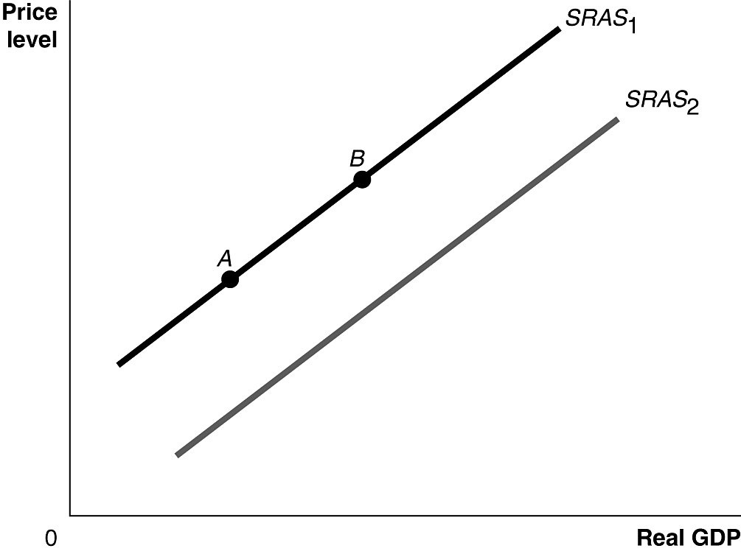
71) Refer to Figure 9.3. Ceteris paribus, an increase in the expected price of an important natural resource would be represented by a movement from
A) SRAS1 to SRAS2.
B) SRAS2 to SRAS1.
C) point A to point B.
D) point B to point A.
E) point 0 to point A.

72) The response of investment spending to an increase in the government budget deficit is called
A) crowding out.
B) expansionary investment.
C) accelerating investment.
D) private dissaving.
E) income minus net taxes.

Table 10.3
Assets | Liabilities
Reserves +$7,000 | Deposits +$50,000
Loans +$46,000 | Net Worth +$3,000

73) Refer to Table 10.3. Consider the following simplified balance sheet for a bank: If the desired reserve ratio is 10 percent, the bank can make a maximum loan of
A) $2,000.
B) $3,000.
C) $5,000.
D) $6,300.
E) $45,000.

74) Active changes in tax and spending by government intended to smooth out the business cycle are called ________, and changes in taxes and spending that occur passively over the business cycle are called ________.
A) discretionary fiscal policy; automatic stabilizers
B) discretionary fiscal policy; conscious fiscal policy
C) active monetary policy; passive monetary policy
D) automatic stabilizers; monetary policy
E) automatic stabilizers; discretionary fiscal policy

75) If the nominal interest rate is 6% and the inflation rate is 9%, then the real interest rate is
A) -3%.
B) 3%.
C) 6.67%.
D) 15%.
E) 25%.

76) If real GDP in a closed economy is $40 billion, consumption is $20 billion, and government purchases are $10 billion, what is investment?
A) $10 billion
B) $30 billion
C) $40 billion
D) $55 billion
E) $70 billion

Table 5.19
Year | Nominal Average Hourly Earnings | CPI  (2002 = 100)
2017 | $23.00 | 119.9
2018 | 23.50 | 121.7
2019 | 24.00 | 122.8

77) Refer to Table 5.19. Looking at the table above, what is the rate of growth of real average hourly earnings from 2018 to 2019?
A) 1.2%
B) 2%
C) 4.3%
D) -1%
E) -1.8 %

78) A government tax rebate of $1,000 would ________ your disposable income by ________.
A) increase; $1,000
B) increase; $500
C) decrease; $1,000
D) decrease; less than $1,000
E) increase; less than $1,000

79) Examples of assets that are included in household wealth would be
A) stocks, bonds, and household appliances.
B) stocks, bonds, and savings accounts.
C) stocks, loans owed, and savings accounts.
D) stocks, bonds, and mortgages.
E) stocks, credit cards, and savings accounts.

80) Workers and firms both expect that prices will be 2.5% higher next year than they are this year. As a result
A) aggregate demand will increase by 2.5%.
B) the purchasing power of wages will rise if wages increase by 2.5%.
C) long-run aggregate supply will shift to the right by 2.5%.
D) workers will be willing to take lower wages next year, but not lower than a 2.5 percent decrease.
E) the short-run aggregate supply curve will shift to the left as wages increase.

